GAME DESIGN DOCUMENT
Sublevel 9
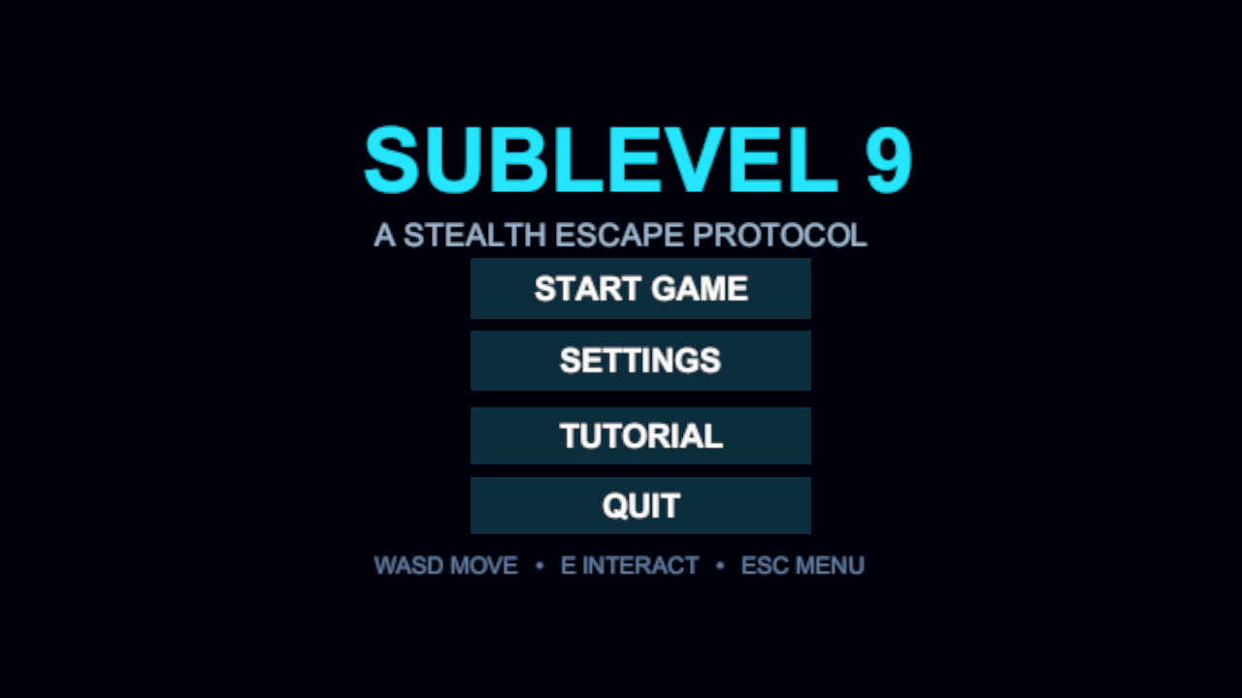

Version: 1.0
Written by: Matej Pfaf
Point of contact: Matej Pfaf (matej.pfaf77@gmail.com)
Date of publishing: September 20, 2026

Table of Contents
- Revision History
- Game Goals
- Story Overview
- Game Controls
- Front End
- Game Camera
- HUD System
- Player Character
- Player Skills
- Health & Death
- Core Game Mechanics
- Enemy AI
- Game Progression
- Game Levels
- Rooftop Finale
- Music and SFX
- Appendixes

Revision History
Version | Date | Author | Changes
1.0 | 09/19/2026 | Matej Pfaf | Initial document

Game Goals

High Concept
"Sublevel 9" is a top-down 2D stealth escape game. The player is trapped on the lowest floor of a facility and has to reach the surface. On each floor the player must avoid patrolling guards and security cameras, route the limited power of the floor, find keycards or codes, and ride the elevator up.
The game has one tutorial level, nine facility levels and a final rooftop level. In the last level the player can shoot for the first time and escapes in a helicopter.

Key Features
- Top-down stealth: patrolling guards see the player by distance and line of sight
- Power routing: terminals switch doors, lights, lasers and elevators, but the power budget of each level is limited
- Keycards and one access code that open locked doors
- Security cameras, a motion sensor and a three-state alarm (Normal, Suspicious, Alert)
- Lockers to hide in and vents to crawl through
- Pushable crates with a pressure plate, laser barriers and unstable timed circuits
- Tutorial level, 9 levels and a rooftop finale with a handgun
- Keyboard and mouse controls
- Background music for every screen, a pause menu and a settings menu

Internet Features
None (single-player offline game).

Story Overview

Setup
The game is subtitled "A Stealth Escape Protocol". The player is trapped on Sublevel 9 of a facility and has to work upward, floor by floor, until reaching the surface. Every floor ends with an elevator or an exit, and it needs power before it works.
The game has no dialogue or cutscenes before the finale. The story is told through the objective text, the room names and the final screens.

Locations
Each level is a different part of the facility:
- Tutorial – training area with two rooms
- Level 1 – Reception and security offices
- Level 2 – Research laboratory
- Level 3 – Central Command (security lobby, surveillance, armory, detention wing)
- Level 4 – Medical wing with a quarantine chamber
- Level 5 – Freight warehouse (storage cage, shipping control)
- Level 6 – Reactor chamber
- Level 7 – AI Core
- Level 8 – Executive vault
- Level 9 – Stealth wing and rooftop access
- Rooftop – helipad on the roof

Finale
On the rooftop the player picks up a handgun and eliminates four guards. The roof then starts to collapse and opens the way to the helicopter. The player walks into the helicopter, it lifts off, the screen fades to black and the win screen appears with the text "ESCAPE SUCCESSFUL – You reached the surface."

Game Controls

Overview
Action | Key
Move | W A S D or Arrow Keys
Interact (terminals, doors, keycards, generators, vents, consoles) | E
Hide in a locker / leave the locker | E
Toggle a system in a power terminal | Number keys (1, 2, 3 ...)
Close a power terminal | E
Pause / Resume | Esc
Aim (Rooftop only) | Mouse
Shoot (Rooftop only, after picking up the weapon) | Left Mouse Button
Menu buttons | Mouse click

Control Scheme
Keyboard and mouse. Movement, interaction and menus use the keyboard and mouse pointer. Shooting exists only in the Rooftop level; every other level has no attack button.
The start screen shows a reminder line: "WASD MOVE • E INTERACT • ESC MENU".

Front End

Title / Start Screen
- Title: "SUBLEVEL 9" with the subtitle "A STEALTH ESCAPE PROTOCOL"
- Buttons: START GAME, SETTINGS, TUTORIAL, QUIT
- START GAME loads Level 1, TUTORIAL loads the tutorial level, QUIT closes the game
- Background: plain dark blue screen with the control reminder at the bottom
- Navigation: mouse cursor; a short sound plays when the cursor enters a button
The start screen is shown on the cover page of this document.

Settings Screen
- Opens when the player clicks SETTINGS on the start screen or in the pause menu
- Sliders: MASTER VOLUME, MUSIC VOLUME, SFX VOLUME
- Toggle: FULLSCREEN
- BACK button closes the panel
- The values are saved on the computer and loaded again next time

Pause Screen
- Opens when the player presses Esc during a level; Esc again resumes
- Freezes the game while open
- Buttons: RESUME, SETTINGS, MAIN MENU
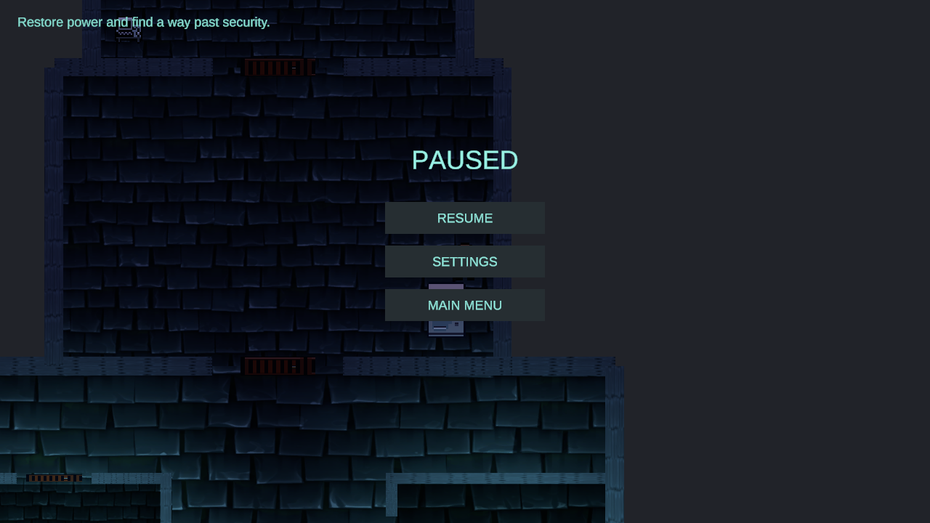

Game Over Screen
- Title: "SIGNAL LOST" with the text "The facility has reclaimed the floor."
- Buttons: RETRY, MAIN MENU, QUIT
- RETRY reloads the level where the player died

Win Screen
- Title: "ESCAPE SUCCESSFUL" with the text "You reached the surface."
- Buttons: MAIN MENU, QUIT

Game Camera
- Top-down 2D view with an orthographic camera (size 7 in every gameplay level)
- The camera follows the player through the level (Cinemachine camera)
- The whole level is not visible at once, so the player has to move to see new rooms
- Rooftop level: the camera shakes for 2.5 seconds when the roof starts to collapse

HUD System
Element | Description
Objective text | One line at the top left of the screen. It shows the current goal, for example "Reach the elevator.", and changes when the player progresses.
Interaction prompt | Text near the bottom of the screen when the player stands next to something usable, for example "E - Hide", "E - Exit Locker", "E - Unlock Door" or "E - Enter Vent".
Feedback message | A short message shown for about 1.6 seconds, for example "Keycard required.", "Elevator has no power." or "Door unlocked.".
Power terminal panel | Opens when the player uses a power terminal. Shows "POWER ROUTING TERMINAL", "Power Usage: x / y", the list of numbered systems with their state and cost, and the hint "E to Close Terminal".
Security camera view | A yellow cone shows what each security camera can see. It is red when the camera sees the player.
Alarm messages | "Security is suspicious..." and "ALERT - security responding!". In Level 3 the screen also gets a red emergency light while the alarm is at Alert.
Crosshair | Rooftop level only. Follows the mouse after the weapon is picked up.
Pause menu | Opened with Esc. See the Front End section.
There is no health bar, timer, score or mini-map.
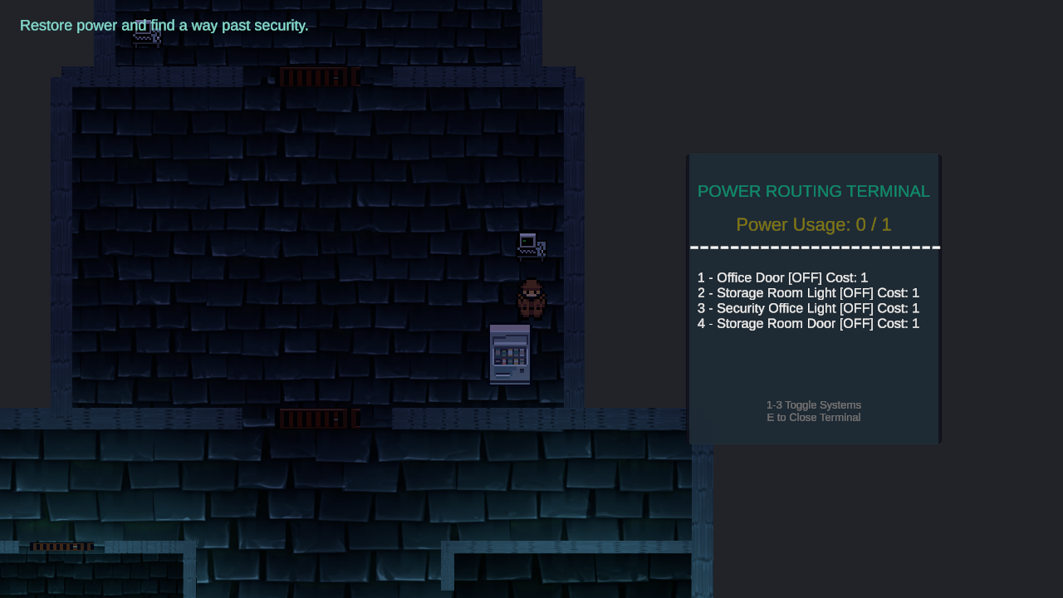

Player Character
Character Name: The player character (unnamed)

Description
A pixel-art character seen from above. The player moves through the facility, avoids guards and cameras and uses terminals. The character has no attack until the rooftop level.

Metrics
- Move Speed: 5 units/second
- Collider: circle with radius 0.5 units
- Physics: no gravity and no rotation
- Health: one hit (no health points)

Movement
- Move in eight directions with WASD or the arrow keys
- Diagonal movement is normalized, so it is not faster than straight movement
- Movement is disabled while a power terminal is open, while hiding and during the final extraction

Player Skills

Basic Skills
- Movement (WASD / arrow keys)
- Interact with objects (E)
- Hide in a locker (E)
- Crawl through a vent to another room (E)
- Route power with terminals (number keys)
- Push crates by walking into them
- Shoot the handgun (Rooftop only)

Skill Upgrades
The player has no skill upgrades. The only upgrade is the backup generator in a level, which raises the maximum power of that level.

Health & Death

Health System
No health bar. The player dies instantly when a guard touches them.

Death Conditions
- A guard touches the player while the player is not hidden
Security cameras, the motion sensor and the alarm do not kill the player. They make guards search for the player. A hidden player cannot be seen or killed by guards.

Death Penalty and Restart
- When the player dies, the game saves the name of the current level and loads the Game Over screen
- RETRY on the Game Over screen reloads that same level from the start
- MAIN MENU goes back to the start screen
- Progress inside a level (keycards, power state) is not saved

Core Game Mechanics

Power Routing
Each level has a maximum power value. Doors, lights, lasers and the elevator are powered objects, and each one costs power. A power terminal lists the objects it controls. The player switches them on or off with the number keys. If the total cost would go over the maximum, the message "Not enough power." appears. The exit of every level needs power before it works.

Generators
A backup generator in a level raises the maximum power of that level when the player uses it. It can be used once and shows the message "Generator activated. Max power: x".

Keycards and Access Code
Keycards are picked up with E and stored for the level. A keycard door opens with E if the player holds the matching card. Otherwise it shows "Keycard required.". Level 7 uses an access code instead of a card: the player reads a maintenance log terminal and the code is saved.

Hiding in Lockers
The player enters a locker with E. While hiding, the player is invisible, cannot move and cannot be seen or killed by guards. Pressing E again leaves the locker.

Security Cameras
A camera sweeps left and right and sees 7 to 8 units far in a cone of 50 to 55 degrees, depending on the level. Walls and closed doors block the view. When a camera sees the player it raises the alarm to Alert and sends all guards to the player's position. A camera console can switch all cameras off.

Alarm System
The alarm has three states: Normal, Suspicious and Alert. A motion sensor makes it Suspicious. A camera seeing the player makes it Alert. Suspicious returns to Normal after 8 seconds and Alert after 15 seconds. An alarm reset console sets it back to Normal at once. While the alarm is at Alert, guards can detect the player from 1.5 times farther away.

Laser Barriers
A laser blocks the way while its power is on. The player switches its power off at a terminal to pass. The message "Laser disabled." appears.

Vents
A vent connects two rooms. The player can enter only when the ventilation fan is switched off at its terminal. Otherwise the prompt says "Fan still running". Pressing E in the vent moves the player to the linked exit.

Crates and Pressure Plates
Crates can be pushed by walking into them. A pressure plate opens its door while the player or a crate stands on it. A crate on the plate keeps the door open.

Unstable Circuits
Some objects get temporary power from an unstable circuit. The power turns itself off after a set time (8 seconds by default) and the object flickers during the last seconds. The player has to move before the power drops.

Darkness
Some rooms are covered by a dark overlay that becomes lighter when the light of that room is powered.

Enemy AI
Guards are patrolling enemies. They cannot be killed in Levels 1–9. They can be shot only in the Rooftop level.

Behaviour
State | Description
Patrol | The guard walks between its patrol points and waits 1 second at each point.
Chase | The guard runs straight to the player at 1.3 times its normal speed (1.4 on the rooftop) while it can see the player.
Search | When the player breaks the line of sight, the guard walks to the last known position and waits 3 seconds. Then it returns to patrol.
Investigate | A camera or the alarm alerts the guard. It walks to the alerted position, waits 2 seconds and returns to patrol.

Detection
- A guard sees the player when the player is closer than the detection range and there is no wall or closed door between them
- Detection range is 4 units in most levels (3.5 to 4.5 in some levels)
- Guards have no view direction. They detect in all directions
- Alarm at Alert: the detection range is multiplied by 1.5
- A hidden player is never detected

Contact
If a guard touches a player who is not hidden, the player dies.

Values
- Patrol speed: 2 units/second
- Chase speed: 2.6 units/second (2.8 in the Rooftop level)
- Player speed: 5 units/second
The player is faster than the guards, so the main danger is being cornered or seen by several guards.

Game Progression
Level | Main Mechanic | Enemies / Hazards | Difficulty
Tutorial | Basics: moving, hiding, power terminal | 1 guard | Easy
Level 1 | Power routing, keycard door, generator | 1 guard | Easy
Level 2 | Security cameras and camera console | 1 guard, 3 cameras | Easy-Medium
Level 3 | Alarm system, motion sensor, alarm reset | 3 guards, 2 cameras, 1 sensor | Medium
Level 4 | Vents and the ventilation fan | 2 guards, 1 camera | Medium
Level 5 | Pushable crate and pressure plate | 2 guards, 1 camera | Medium
Level 6 | Unstable timed circuit | 2 guards, 1 camera | Medium-Hard
Level 7 | Access code and laser barrier | 3 guards, 1 camera, 1 laser | Medium-Hard
Level 8 | Two authorization cards | 3 guards, 1 camera, 1 laser, alarm | Hard
Level 9 | All mechanics combined | 5 guards, 2 cameras, 2 lasers, 2 timed circuits, alarm | Hard
Rooftop | Combat with a handgun | 4 guards | Hard
Difficulty is an estimate based on the number of guards and hazards in each level.
The player goes from one level to the next through the elevator. Level 9 ends at the rooftop access, which leads to the Rooftop level. The Rooftop level ends with the win screen.

Game Levels

Tutorial – Training Level
The tutorial is a separate level opened with the TUTORIAL button. It is not part of the START GAME path. Its elevator leads to Level 1.
Objective: "Learn the basics and reach the elevator."
Contents: Two rooms, a power routing terminal, a door, a locker, a dark room and one patrolling guard. The terminal has a maximum power of 3.
Reward: Access to Level 1.
Visual Style: Dark blue tiled rooms.

Level 1 – Reception and Security Offices
Objective: "Restore power and find a way past security." The player finds the keycard, unlocks the security door and reaches the elevator.
New Mechanics: Power routing with a small budget (maximum power 1), keycard and keycard door, backup generator, locker, darkness in the open office.
Reward: The backup generator raises the maximum power from 1 to 4. The elevator leads to Level 2.
Visual Style: Dark blue tiled offices.
The level has four terminals, one guard and a locked security door in front of the elevator hall.

Level 2 – Research Laboratory
Objective: "Restore auxiliary power.", then "Disable the security cameras.", "Find the security access card." and "Reach the elevator."
New Mechanics: Security cameras (3) and the camera control console.
Reward: The generator raises the maximum power from 1 to 5. The elevator leads to Level 3.
Visual Style: Blue-green laboratory rooms with yellow camera view cones.
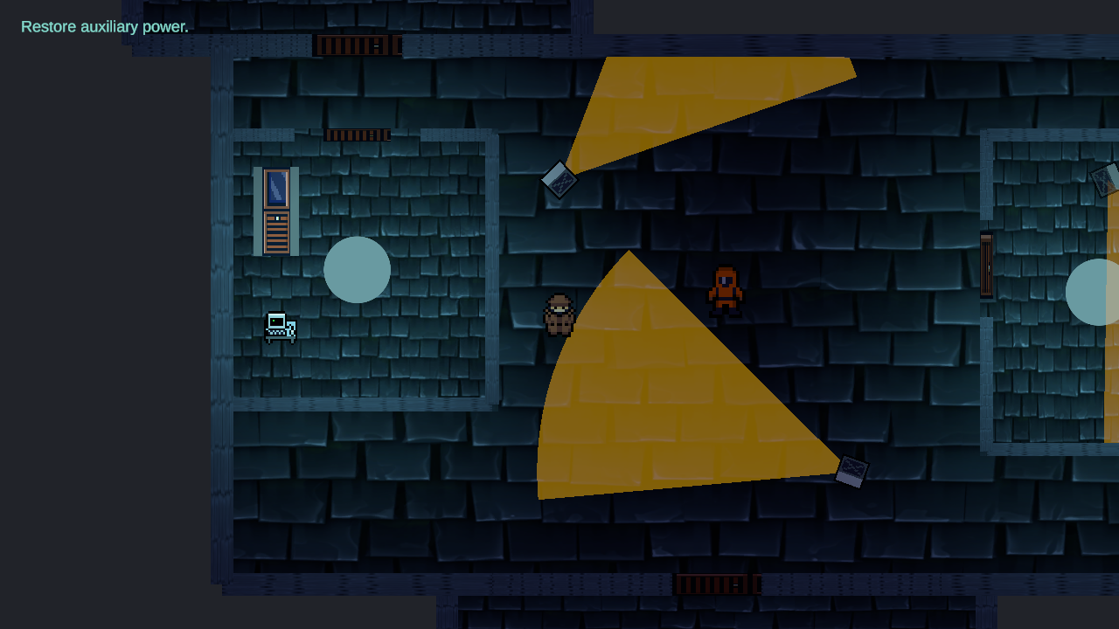

Level 3 – Central Command
Objective: "Explore Central Command and reach the elevator." The player needs the detention access card to open two doors.
New Mechanics: Alarm system, motion sensor and alarm reset console. After the alarm turns to Alert the objective becomes "Reset the alarm at a security console."
Reward: The generator raises the maximum power from 4 to 6. The elevator leads to Level 4.
Visual Style: Dark rooms. The screen gets red emergency lighting when the alarm is at Alert.
The level is a hub with a surveillance center, an armory corridor and a detention wing around it.
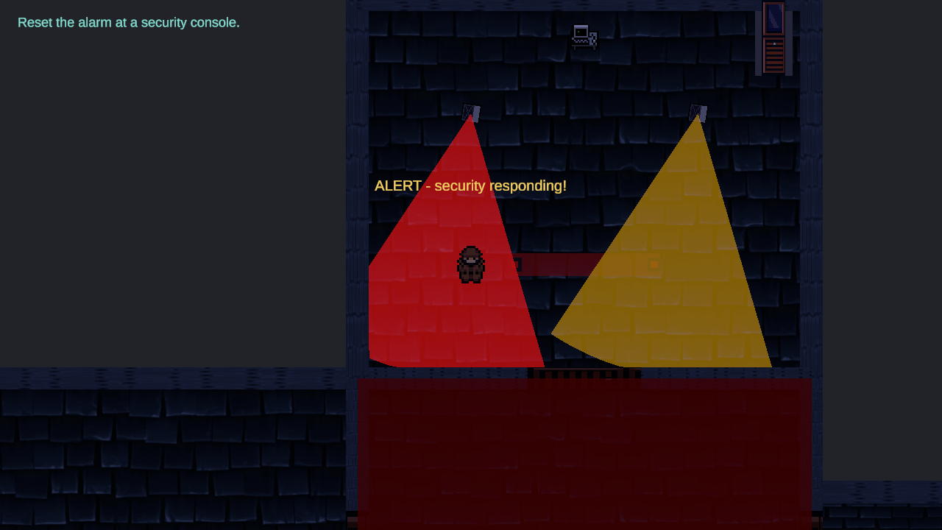

Level 4 – Medical Wing
Objective: "Restore auxiliary power and explore the medical wing." The player finds the medical access card and reaches the elevator.
New Mechanics: Vents. The player must switch off the ventilation fan at a terminal before entering a vent.
Reward: The generator raises the maximum power from 4 to 6. The elevator leads to Level 5.
Visual Style: Dark blue tiled medical rooms (patient ward, operating room, quarantine chamber). The operating room stays dark until its light is powered.

Level 5 – Freight Warehouse
Objective: "Find a way into the Storage Cage." The player gets the freight access card and then reaches Shipping Control and the elevator.
New Mechanics: Pushable crates and a pressure plate.
Reward: The generator raises the maximum power from 4 to 6. The elevator leads to Level 6.
Visual Style: Warehouse hall with rows of shelves, wooden crates and red pressure plates.
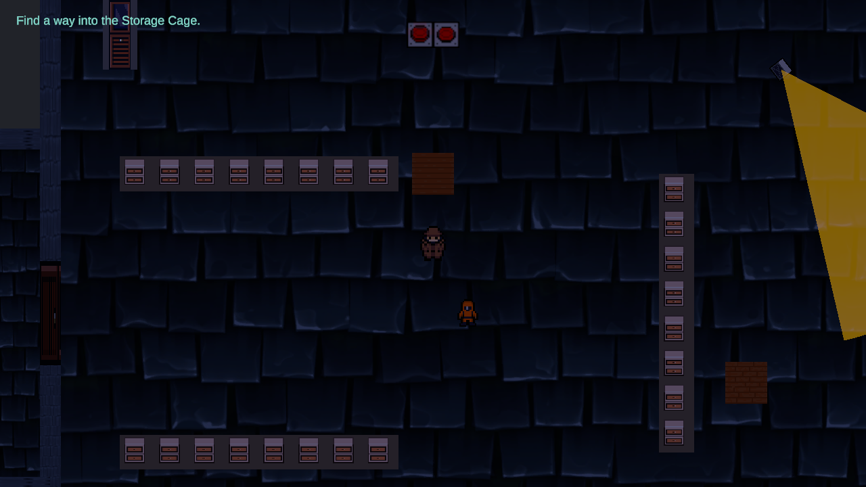

Level 6 – Reactor Chamber
Objective: "Cross the reactor chamber and reach the elevator."
New Mechanics: Unstable circuit: a walkway door gets temporary power for 24 seconds and warns 5 seconds before the power drops.
Reward: The generator raises the maximum power from 4 to 6. The elevator leads to Level 7.
Visual Style: Dark hall with a glowing blue reactor core in the middle.

Level 7 – AI Core
Objective: "Find the AI Core override code." then "Disable the laser and reach the AI Core."
New Mechanics: Access code (read from a log terminal) and a laser barrier that is switched off at a terminal.
Reward: The generator raises the maximum power from 4 to 6. The elevator leads to Level 8.
Visual Style: Server corridors and rooms with a red laser barrier.

Level 8 – Executive Vault
Objective: "Acquire Authorization A and Authorization B." The cards are needed to open the vault. Then the player reaches the vault and the elevator.
New Mechanics: Two separate authorization cards. The east wing has a laser and the west wing has the alarm and a camera. The level also has vents.
Reward: The generator raises the maximum power from 4 to 6. The elevator leads to Level 9.
Visual Style: Executive lobby, conference hall, archive and vault in the same dark tile style.

Level 9 – Stealth Wing and Rooftop Access
Objective: "Explore the facility and prepare for the rooftop." The player gets both rooftop keycards, restores rooftop access and reaches the rooftop exit.
New Mechanics: No new mechanic. The level combines cameras, alarm, lasers, vents and two timed circuits (10 and 8 seconds). When the alarm is at Alert the objective is "Break line of sight and wait for the alert to fade."
Reward: The generator raises the maximum power from 5 to 8. The exit leads to the Rooftop level.
Visual Style: Dark corridors with red lasers, yellow camera cones and alarm messages.
This level has the most guards of the facility levels (5).
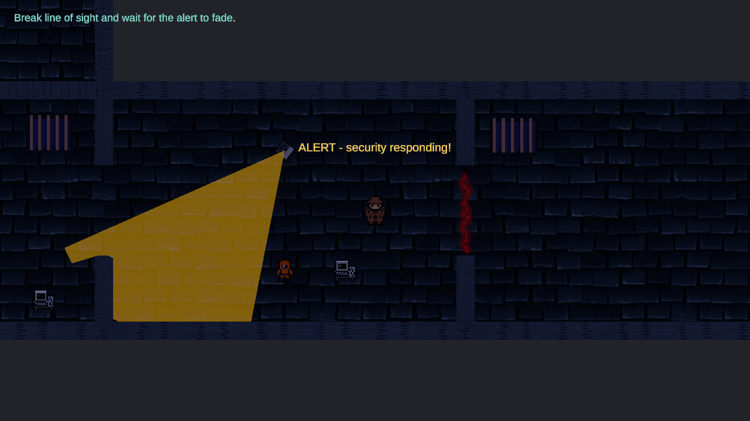

Rooftop Finale
Objective: "Find a way to reach the helipad." After the weapon is picked up: "Eliminate rooftop security — 0 / 4". After the guards are down: "Reach the helicopter."
New Mechanics: Weapon pickup, shooting and killable guards. This is the only level where the player can attack.
Reward: Escape from the facility and the win screen.
Visual Style: Outdoor roof with a stone floor, air conditioning units, satellite dishes, crates, a helipad and a helicopter.

Weapon
- The handgun is picked up with E ("Weapon acquired.")
- The weapon aims at the mouse and fires with the left mouse button
- Fire rate: 4 shots per second
- Damage: 1 per shot
- Range: 9 units (instant hit, with a muzzle flash and a short tracer)
- A crosshair follows the mouse
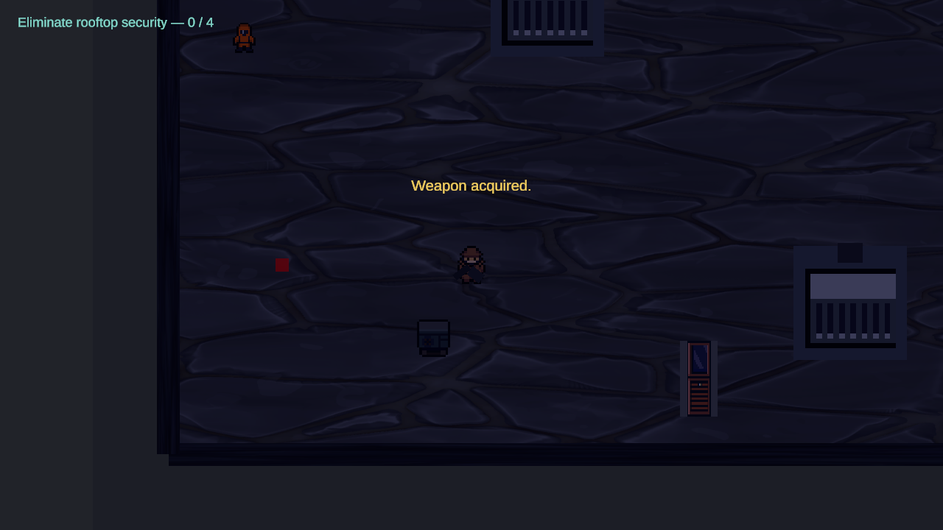

Guards
- 4 guards, each with 3 health points (three hits to kill)
- A guard flashes white when hit and fades out when killed
- The guards still kill the player on touch
- The objective counter shows the kills, for example "Eliminate rooftop security — 2 / 4"

Roof Collapse
One second after the fourth guard dies, the message "Structural failure detected!" appears. The camera shakes for 2.5 seconds, explosion effects play, and the barrier that blocks the way to the helicopter slides up and away over 1.5 seconds. The objective changes to "Reach the helicopter."
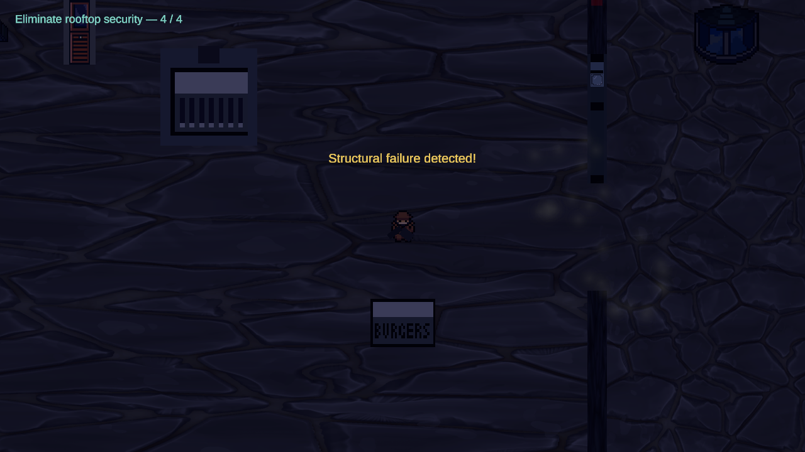

Extraction
When the player enters the helicopter trigger, control is taken away. Guards stop and the player walks to the helicopter. The player and the weapon disappear, the message "Extraction complete." appears and the helicopter lifts off 15 units. Then the screen fades to black over 1.5 seconds and the win screen loads.
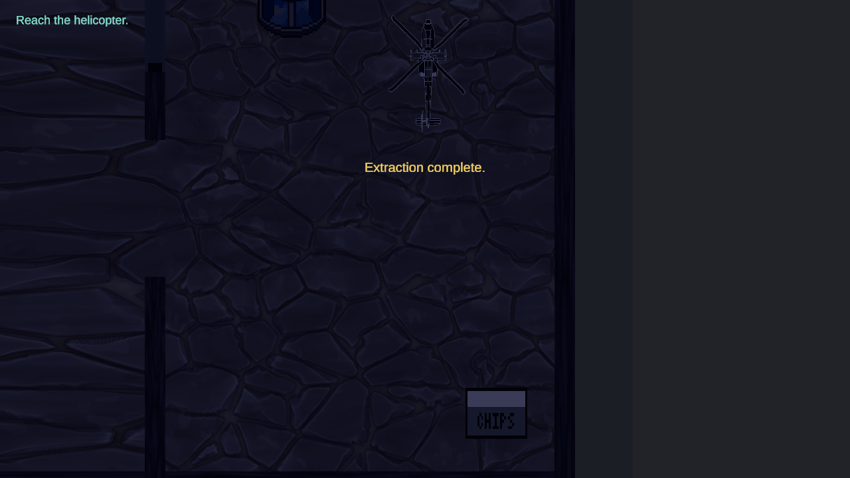

Music and SFX

Music List
Location | Track | Status
Start screen | title.mp3 | Implemented
Tutorial and Levels 1–9 | sector.mp3 | Implemented
Rooftop | urgent.mp3 | Implemented
Win screen | transmission.mp3 | Implemented
Game Over screen | pulse.mp3 | Implemented
The music plays at volume 0.2 and changes with a crossfade of about 0.8 seconds when the scene changes. Moving between levels keeps the same track playing. The tracks airy.mp3, victory.mp3 and everything_is_dead-sci-fi-ambient-dark-ambient-496940.mp3 are in the project but are not used.

Sound Effects
Sound | Action
hover.mp3 | The mouse cursor enters a menu button (played once, volume 0.25)
No other sound effects are implemented. Gameplay actions such as walking, shooting, doors and the alarm are silent.

Appendixes

In-Game Text
Screen / Situation | Text
Start screen | "SUBLEVEL 9", "A STEALTH ESCAPE PROTOCOL", "WASD MOVE • E INTERACT • ESC MENU"
Pause menu | "PAUSED", "RESUME", "SETTINGS", "MAIN MENU"
Game Over | "SIGNAL LOST", "The facility has reclaimed the floor."
Win | "ESCAPE SUCCESSFUL", "You reached the surface."
Power terminal | "POWER ROUTING TERMINAL", "Power Usage: x / y", "E to Close Terminal"
Locked door | "Keycard required."
Door opened | "Door unlocked."
Elevator without power | "Elevator has no power."
Not enough power | "Not enough power."
Vent | "E - Enter Vent" / "Fan still running"
Alarm | "Security is suspicious...", "ALERT - security responding!", "Alarm reset."
Unstable circuit | "Temporary power activated.", "Power dropped."
Rooftop | "Weapon acquired.", "Structural failure detected!", "Extraction complete."

Key Scripts
Script | Purpose
PlayerMovement, PlayerInteract, PlayerStealth | Player movement, interaction with E, hiding
EnemyAI | Guard patrol, detection, chase and contact
SecurityCamera, AlarmController, SecuritySensor | Cameras and the alarm states
PowerManager, PoweredObject, MultiPowerTerminal | Power budget and power terminals
KeycardPickup, KeycardDoor, CodeClueTerminal | Keycards and the access code
VentPassage, PressurePlate, PushableCrate, LaserBarrier, UnstableCircuit | Level puzzles
PlayerHealth, GameProgress, SceneLoader | Death, saving the current level and scene loading
PlayerWeapon, EnemyHealth, RooftopCollapseSequence, RooftopSequence | Rooftop combat, collapse and extraction
MusicManager, ButtonHoverSound | Music and menu sound
PauseMenuController, GameSettings | Pause menu and saved settings

Screenshot List
- Start screen (cover)
- Pause screen
- Power routing terminal in Level 1
- Level 2 with security cameras
- Level 3 with the alarm at Alert
- Level 5 with crates and pressure plates
- Level 9 with laser, camera and alarm
- Rooftop: weapon acquired
- Rooftop: roof collapse
- Rooftop: extraction

